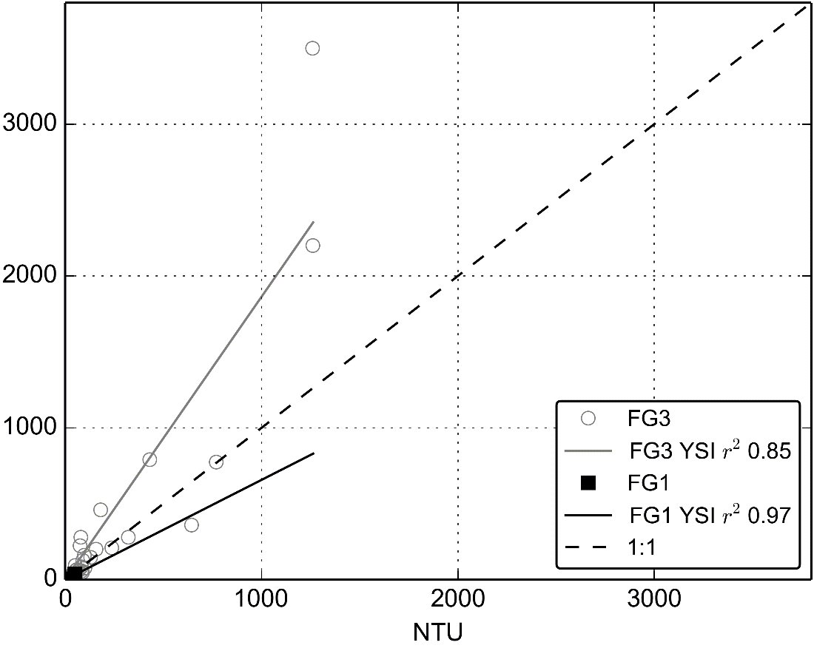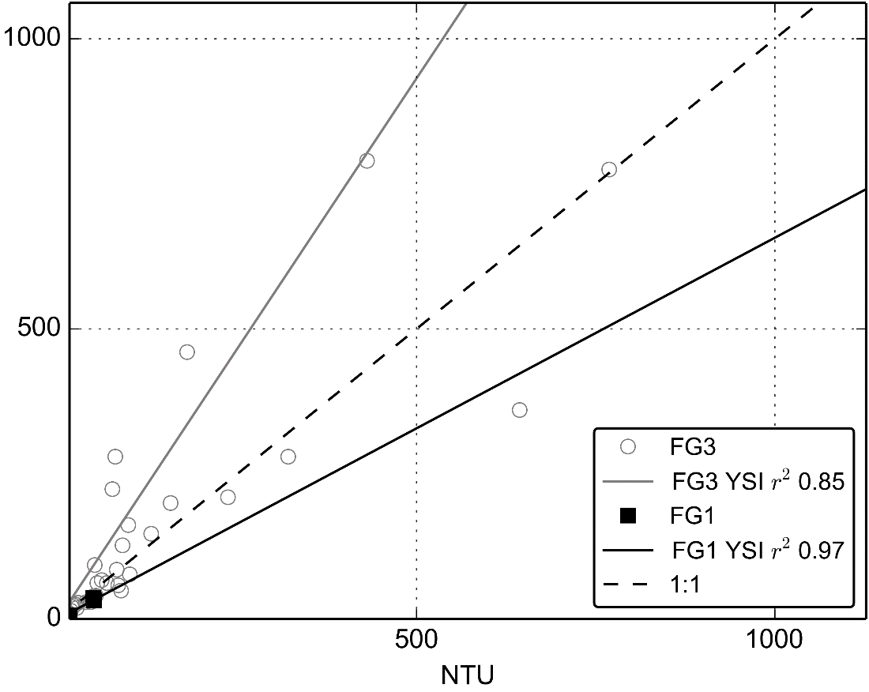

3/5/12 1500

3/5/12 1700

2/6/12 1700

3/5/12 1500

2/6/12 1130

3/5/12 1700

3/5/12 1630

3/5/12 1600

Storm 2/6/2012

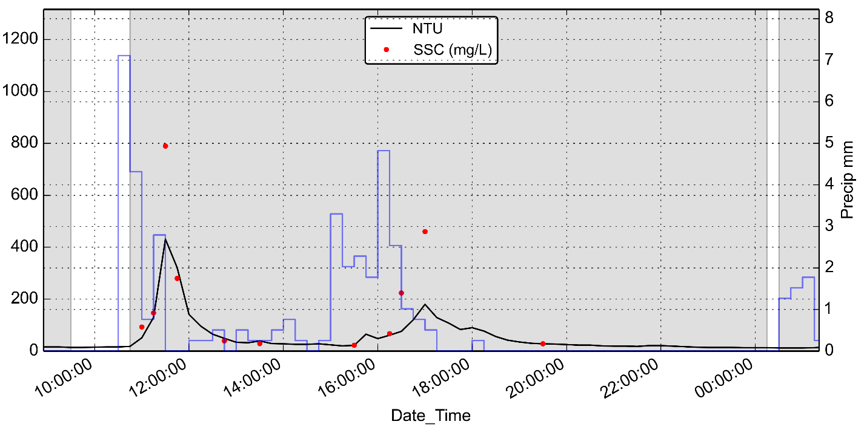

Storm 3/5/2012

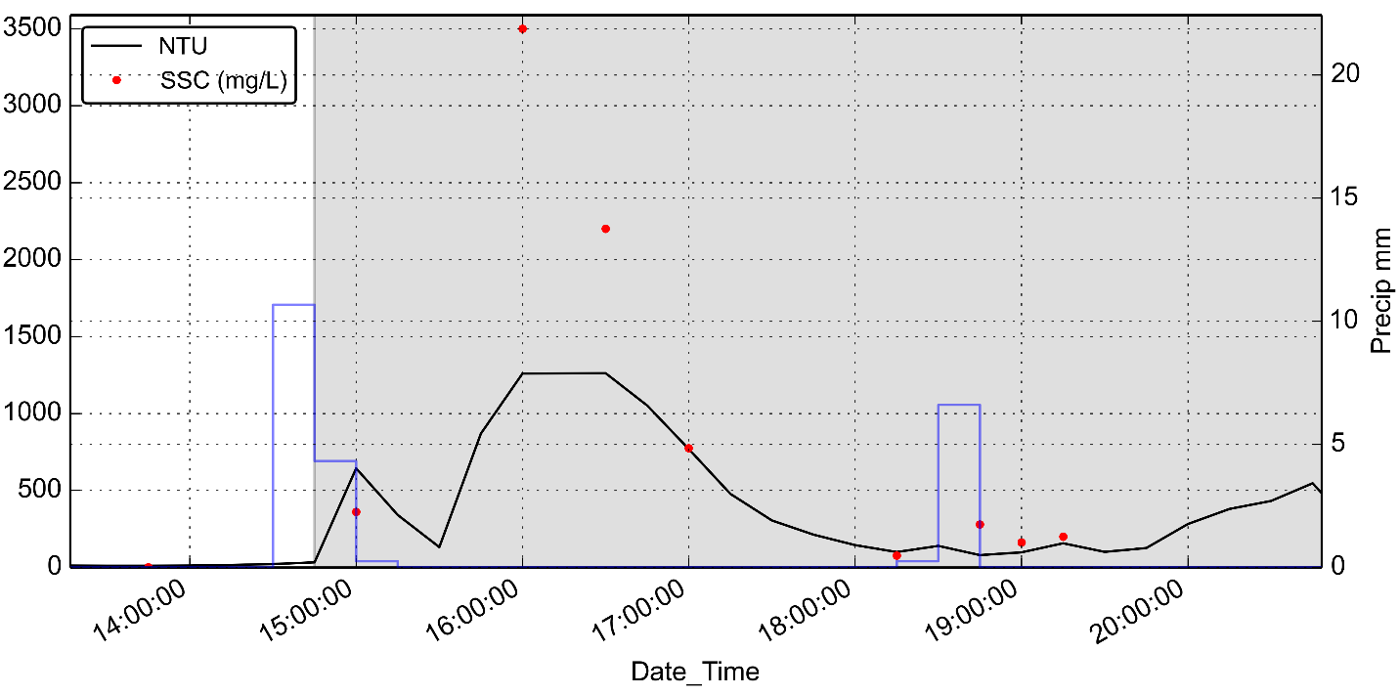

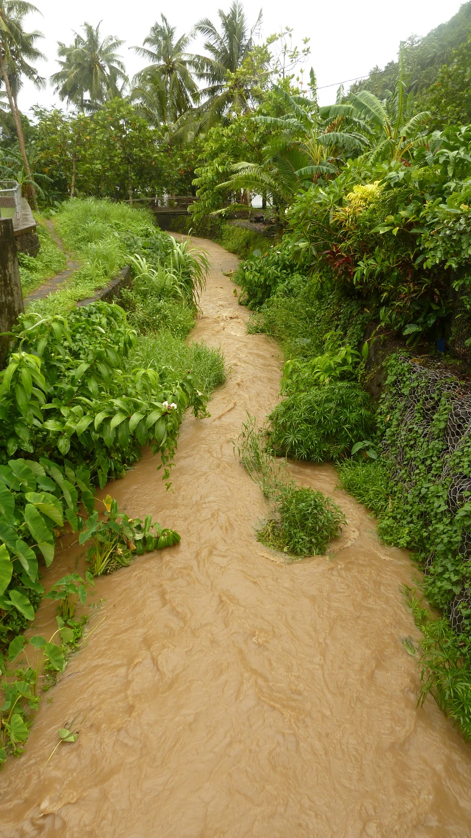

Storm 2/6/2012 Camera Time: 1440; Local Time: 1140 (I think this is the peak SSC for the event = 800 mg/L)

Journal entry:

Day 32-Feb.6,2012 Rainy all day

It rained a lot last night and today. Very windy also, a cyclone is passing to the south. Went straight to Faga’alu and started sampling. Retrieved samples from Autosampler. Rocco met me at LBJ and we went into the lab. He filtered samples all day and I went back to get the Autosample battery to take home for a charge. Got more samples and we filtered all of them, what a huge help to have another person. This seemed like a significant rain. Highest stage I’ve seen yet.

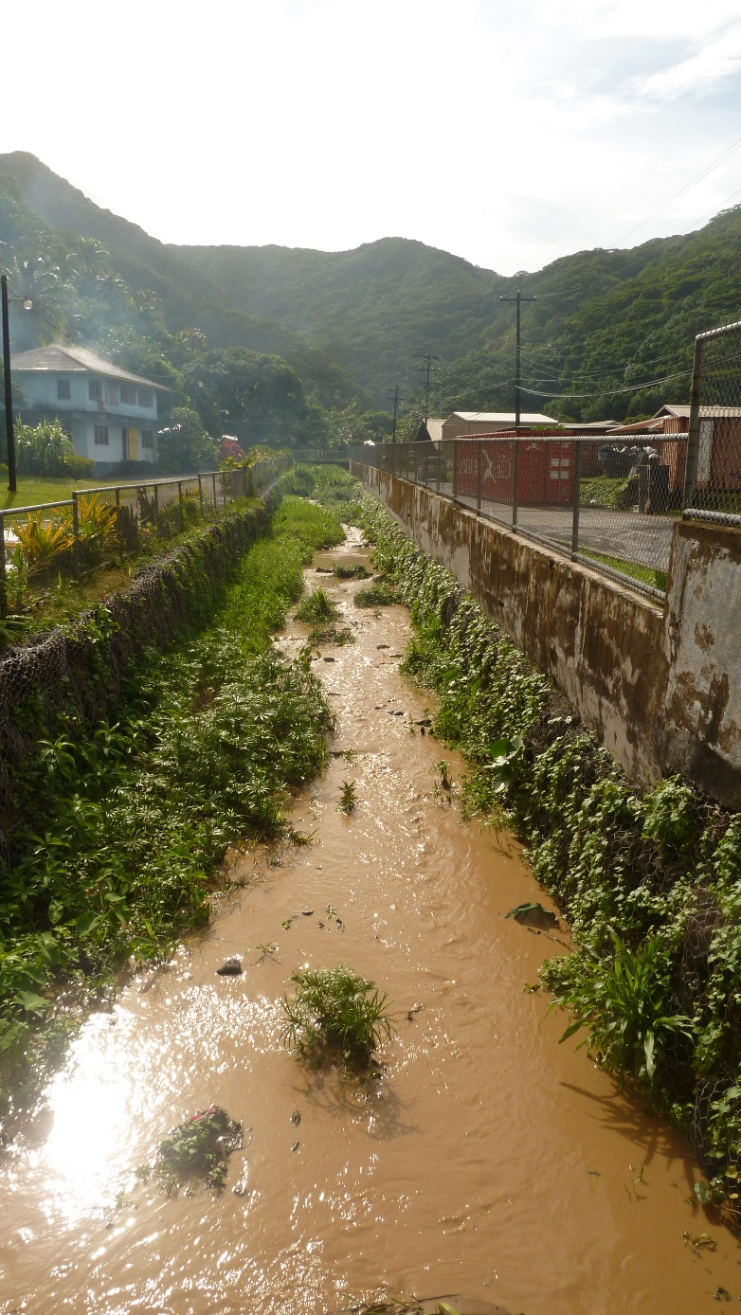

Storm 3/5/12 Camera Time: 1915; Local Time: 1615 (Prob event peak SSC = 3,500 mg/L)

Journal entry:

Day 60-March 5, 2012

Swapped out batteries on YSI (piece of…) and it died after 2 days. I got new batt’s at the store, hopefully those go better. The Argonaut was dead too so I took that battery home and charged it and swapped it in. I got 2 new batt’s for it at DOC. Sieved reef trap 1A-Tile but there’s no 63um sieve and I forgot to save the fines fraction. Put the samples in to dry. Went to Aeto to try to take care of insurance, still need the title though. It started raining so I went back to Faga’alu and sampled extensively. Went home for a quick meal and a regroup and came back to Faga’alu just in time for another rain, got more samples. Late night in the lab filtering til 1130. Samoans are so damn friendly the security guard, Dimitri, hung out with me and took videos on his iPhone. He was all excited to see a “real scientist” at work.